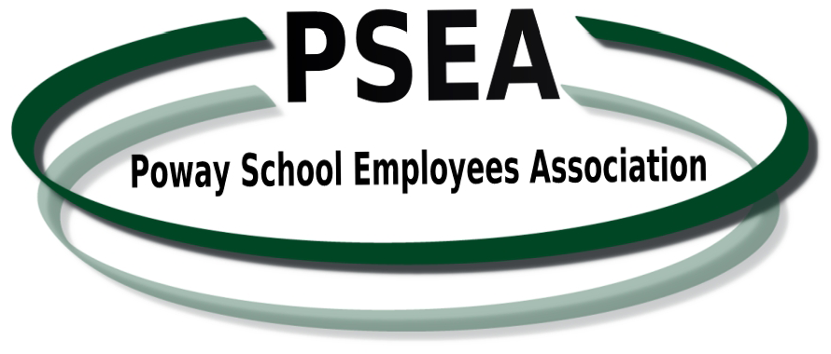 |  | Regular Meeting of  THE MEMBERSHIP and BOARD OF DIRECTORS  PSEA Administrative Offices  13378 Poway Road, Poway, CA 92064  May 16, 2016  AGENDA
Closed Session  3:00 p.m. to  3:20 p.m. | CALL TO ORDER OF BOARD MEMBERS  GENERAL COUNSEL: PERSONNEL, GRIEVANCE AND LITIGATION REPORT
Board of Directors  Meeting  3:20 p.m. to  4:30 p.m. | - QUORUM CALL/CALL TO ORDER  - REVIEW AND APPROVAL OF MINUTES OF BOARD OF DIRECTORS MEETING  - REPORT OUT FROM CLOSED SESSION  - OFFICER REPORTS  - GENERAL COUNSEL’S REPORT  - GENERAL ORDERS  - GO2016-05-01. Approve Budget for 2016-2017  - MO2016-05-01. Approve initial start-up contribution to RESPECT Fund for July 1, 2016 with allocation previously approved in April 2015.  - MO2016-05-02. Approve release time for Officers 2016-2017  - COMMITTEE REPORTS  - UNFINISHED BUSINESS  - Stipends for Officers  - NEW BUSINESS  - Summer Leadership Workshop & Training  - ADJOURN TO MEMBERSHIP MEETING
Membership  Meeting  4:45 p.m. to 5:45 p.m.  FOOD  DRINKS  PRIZES | - CALL TO ORDER  - CELEBRATION OF CLASSIFIED EMPLOYEES  - GUEST SPEAKER – Bruce Smith, Financial Literacy 101  - MEMBERSHIP COMMENTS  Members are encouraged to bring issues of concern to the Board. This section is for information purposes only; items requiring decisions will be placed on a future agenda for disposition.  - GOOD OF THE ORDER  - ADJOURN

