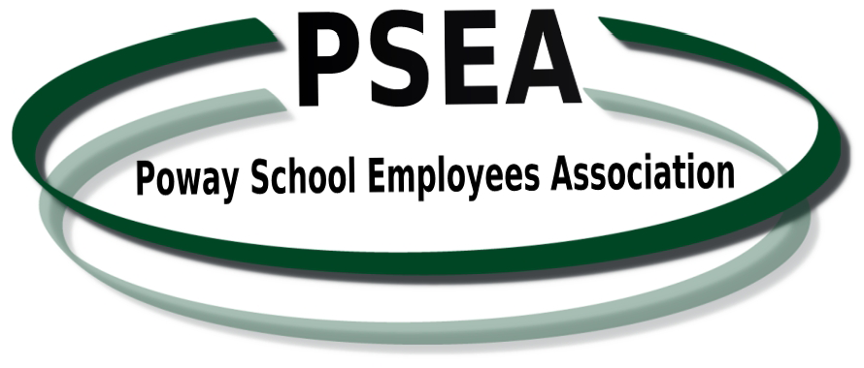 |  | Regular Meeting of  THE MEMBERSHIP and BOARD OF DIRECTORS  PSEA Administrative Offices  13378 Poway Road, Poway, CA 92064  September 15, 2015  AGENDA
Membership  Meeting  4:45 p.m. to 5:45 p.m. | - GATHERING – DINNER  - CALL TO ORDER  - INSTALLATION OF SITE REPRESENTATIVES  - SPEAKERS – MEMBER Q&A  Corrie Amador, Personnel Commission Director  Courtney Martin, Professional Learning Coordinator  - COMMITTEE REPORTS  Yoenda Dornan, Scholarship Committee  Scholarships Available  Marcelle, Benefits and Recreation Committee  Family Picnic  Retirement Seminars  - OFFICER REPORTS (Members will have the opportunity for questions and answers after each officer report.)  - PRESIDENT’S REPORT  - Negotiations  - Current Employee Issues  - School Board Meeting Report  - VICE PRESIDENT’S REPORT  - Personnel Commission Meeting Report  - SECRETARY’S REPORT  - TREASURER’S REPORT  - Membership report  - September is Member Month!  - Financial report  - PARLIAMENTARIAN REPORT  - MEMBERS AT LARGE REPORT  - GOOD OF THE ORDER  - ADJOURN TO BOARD OF DIRECTORS MEETING
Board of Directors  Meeting  5:45 to 6:15 p.m. | - QUORUM CALL/CALL TO ORDER  - REVIEW AND APPROVAL OF MINUTES OF BOARD OF DIRECTORS AND MEMBERSHIP MEETING  - MEMBERSHIP COMMENTS - Discussion is limited to items not on today’s agenda. Board will set a future date for discussion of the item and place it on the agenda where appropriate.  - GENERAL ORDERS  - None.  - UNFINISHED BUSINESS - None  - NEW BUSINESS  - ADJOURN TO CLOSED SESSION
Closed Session  6:15 to 6:45 p.m. | CALL TO ORDER OF BOARD MEMBERS  GENERAL COUNSEL: PERSONNEL, GRIEVANCE AND LITIGATION REPORT

REPORT OUT ON CLOSED SESSION
- ADJOURN

